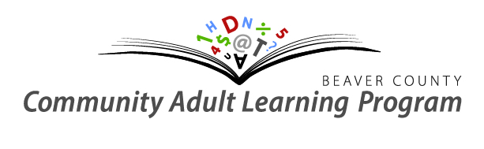
Contact Beaver County CALP
New Futures
Career Transitions Workshops

Dates: November 25 – 29, 2019
Time: Monday – Friday, 9:00am – 4:00pm
Place: Beaver County Service Centre, Ryley
5120 50 St. Ryley

30 hours of web conferenced workshops broken into ½ day sessions covering:
Resume and Cover Letter Writing,
Networking and Interview Skills,
Managing Change and Job Loss,
And Career Services.
You can attend all or choose the sessions that are of most interest to you!

There is an on-site instructor to assist you with your learning during class times.

Registration DEADLINE IS Wednesday, November 20 – 4 pm

Phone: 780 663 3730 Website: www.beavercountycalp.ca Email:calp@beaver.ab.ca
